The Centre for Human Energy Field Research
EXETER UK WORLD PEACE CENTRE PUNE INDIA London, UK

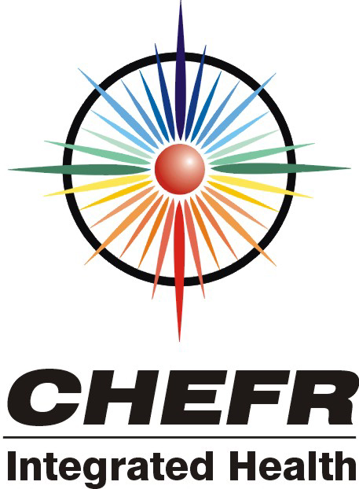

Energy Field Imaging with
Polycontrast Interference Photography

Pune, India. April 2004

Dr Thornton WJA Streeter D.Sc. BRCP
And John R Rogerson.

Affiliated to the Institute of Complementary Medicine No: A573

Introduction to the Human Energy Field
Its Role in the Future of Healthcare

The Human energy field (HEF) is a holographic projected lattice of primarily light and sound emanating from a twin poled core at the centre of the human body with multiple interpenetrating layers.

The EF has often been seen, described and depicted in religious and spiritual writings dating back to the earliest writings. Dennis Milner in his book the Loom of Creation recounts his observations of distinct body field layers with circular and triangular structures in differing layers.

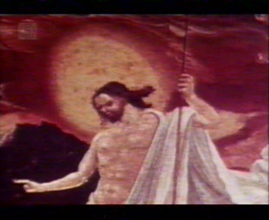
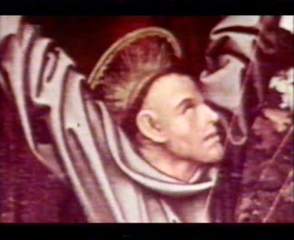
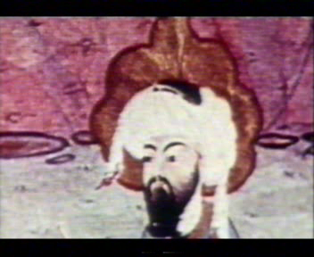
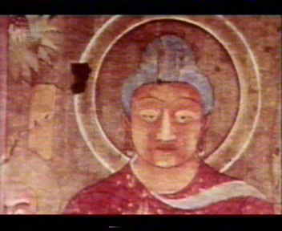
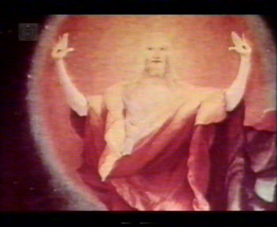
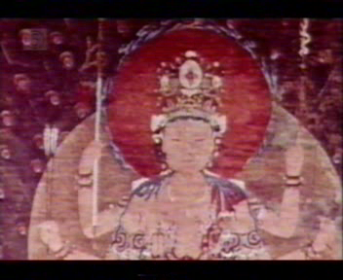

Up until the early 20th century, detection of the energy field (EF) remained in the hands of certain gifted individuals, including clairvoyants whose enhanced range of ‘sight’ allowed them to detect energy fields, either through their visual sight or through the more etheric ‘third eye’ brow chakra (chakras are energy gates into the energy field, described later) .

The EF is composed of electro-magnetic and bio-dynamic radiations that can be measured against the Electro-Magnetic Spectrum with a variety of different devices; SQUID, ESM, BEST, PIP, Electrography, Radionics, ACMOS (Lescher) Antennae, Bio-feedback metre and GDV to name a few.

The HEF is a protective sheath which can be punctured and torn leading to illness and disease. It is a blueprint for where and how our physical body hangs in space and time. Changes in the physical/emotional health status of an individual are reflected and can thus be detected in their HEF (and vice versa). Indeed practitioners of complementary and alternative therapies (CAM) including eastern medicines such as acupuncture believe that physical/emotional imbalances (including disease) are caused by and thus preceded by disturbances in the energetic body. It seems more likely that not only does the energetic matrix effect the physical/emotional body’s health but so too can the reverse be true.

Vibrational Medicine

Based on such concepts, there now exists a whole body of medicine termed energy or vibrational medicine. This approach acknowledges the non-physical (subtle energetic) make-up of the body and seeks to treat disease by releasing energy blockages and imbalances. In turn this helps to rebalance and sustain the physical/emotional body’s health. It is the case that when a broken bone is left it will eventually heal itself leaving no pain, but with limited durability, mobility and strength. However if the bone is repositioned to set in the correct manner then full durability, mobility and strength can return. The same is true with the HEF. Any damage to the physical/emotional system will be reflective of a corresponding weakness in the EF. If no attention is given to the underlying energy matrix then any repairs carried out on the physical/emotional body will be done upon an unsound energy matrix and thus have limited durability, mobility and strength.

As a result of increased interest in this field (as well as all aspects of complementary and alternative medicine, CAM) there is naturally a growing scientific interest in the search for objective, valid and reliable methods of measuring bio-energetic health status.

“An ability to detect illness and energetic disturbances reliably and accurately in a person’s etheric body days or weeks prior to the appearance of actual physical symptoms would be truly miraculous”
(Richard Gerber, 2000)

The past few decades have seen large advances in the CAM field. There are protocols in place to rigorously examine the efficacy and safety of these treatment modalities so that they may be incorporated into the modern healthcare arena. However, a common complaint of CAM practitioners is that the clinical research being carried out to test their validity is not performed in a manner which complements their given modality i.e. takes no account of the mechanism involved. It is apparent to CHEFR that the majority of CAM therapies involve an energetic component, as part of the healing or treatment process, and thus an assessment procedure that considers all these aspects would seem necessary. Omitting this intertwined variable could go some way to explaining why many of these research papers have found erroneous, often conflicting results.

The Atlas of Disease States (AODS)

The AODS is shortened from the Atlas of Human energy Field images and data collated to reveal the stages of each Disease State to triangulate an individual’s health trajectory.

CHEFR constructed a model of disease stages based on seven distinct stages of manifestation. These different levels are measured against an axis of time and are sub- divided from three major groups- pre-medical, medical and post- medical. It is possible to calculate an individual’s health trajectory well before symptoms would give rise to a diagnosis that is sadly often too late to initiate a program of healing.

Primary pre-symptomatic is the first stage of disease manifestation and can be seen as congestion or a leak in the HEF meridians or energy channels. The acupuncture points therefore reveal this primary stage long before the individual feels any pain, hence the tradition in China where the community paid the doctors to keep them healthy and were reimbursed if ever taken ill- pioneering holistic insurance!

Secondary pre-symptomatic is reached when the imbalance affects the Chakras in the HEF so this throws out the body’s natural self-healing mechanism.

Primary symptomatic – now imbalances can be detected the HEF over the organs that will be afflicted as the disease takes its physical manifestation. Earliest pathological test would now reveal this imbalance.

Secondary symptomatic with pain. By now the individual concerned is feeling pain so is on his way to see his GP or local doctor and his symptoms will reveal the right treatment that will cure his disease.

Acute - depending on the type and severity of the condition any number of different treatments and assessment techniques would reveal and affect different aspects of the illness. The best model is one that evaluates each case individually to work out the most cost effective and least invasive treatment that would be appropriate.

Chronic in many cases a simple cure is not available and the physical body is often affected in a degenerative way. Many modern scanners can witness the impact of chronic disease in the body including CAT MRI X-ray

Terminal or remission All lives end and some believe at a pre ordained time – there are amazing stories of remissions often linked to a positive outlook and a desire to first understand and then lift the imbalance back into equilibrium.

Our work is now collating a database of disease stages known as the Atlas of Diseases. It is a well known fact amongst energy workers around the world that energy field imbalances can be detected before they manifest in the physical body. This interactive program allows the practitioner to compare any patient’s energy field profile with a database of others recordings. Comparison could be made to both previous instances that the individual has been scanned (to track the progress of recovery) and also with other individuals with known pathology. This will be done using a range of different analysis programs such as pattern recognition and size averaging. When finding similar matches the system highlights consistencies in both the medical records and in the scans of other matches.

The Atlas of HEF ‘maps’ and evaluating the onset of each disease state

Correlation occurs by cross-referencing, pattern and colour recognition, banding, intersections and chakra and meridian activity in terms of both congestion and leaks.

For instance a set of PIP energy field images will be taken along with BEST and ESM readings. These results are correlated, via online communication, through the Atlas of Disease database. Similar case studies that match the new client’s data are collated together in a ‘computerised basket’ which then analyse the data to see if similar symptoms are revealed. This will lead to a statistical probability rating of possible energy field matrix weaknesses that can be addressed to prevent the possible further manifestation of disease.

Health Prediction & triangulating an individual’s Health Trajectory.

This new concept, pioneered by Dr. Thornton Streeter is based on the benefit that new technological advances in holistic diagnosis allow us to identify an individual’s unique health position before the physical manifestation of a disease. Dr Streeter believes that the energy field is the matrix upon which our physical bodies hang. Other scientific researchers and pioneers have also followed this understanding. (McTaggart, 2001)

The concept of establishing an individual’s health trajectory is not new; any doctor can be heard explaining the likely progression of symptoms to a patient. However, in terms of preventative medicine to work it must be able to reliably track a person’s journey into a particular disease. The soundest method of predictive validity is to correlate results gained from any test with a past database of results. This process can identify and point towards possible developing diseases that can then be prevented from manifesting within the physical body.

This would transform global healthcare, its efficiency and cost-saving in time and materials! Thus far the main control system for establishing the health trajectory is Polycontrast Interference Photography (PIP) combined with the electro-scanning method (ESM – See School of Electro-Crystal Therapy).

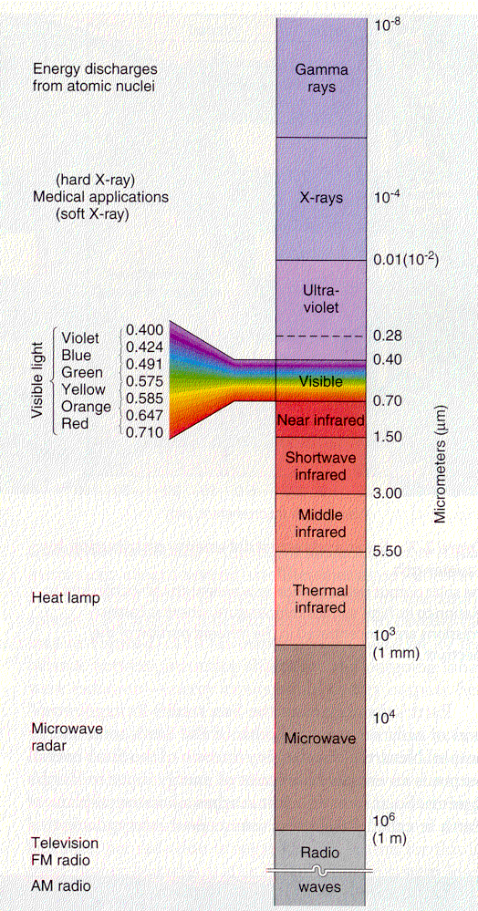
The Electromagnetic Spectrum
The EMS is the ‘ruler’ upon which all Vibrational frequencies lie. The EMS is of particular interest to CHEFR because it is clear in the history of medical device development that the human body can be measured at many different levels on the EM spectrum. CHEFR is investigating whether there are more non-invasive, more predictive and more cost effective systems which evaluate our bodies in hitherto unutilised windows on the EMS.
As far as the medical sciences are concerned you will often find a device whose scanning spectrum can be related to a particular window of the electromagnetic spectrum. X-rays are produced by a wide range of medical devices in a modern healthcare environment, whether for dentistry or for assessing fractured bones. In the same way, ultrasound is used both to check the health of an embryo as well as for the removal of kidney stones. Here are two devices each with their own range on the EMS.
In CAM research over 3000 papers have been published concerning the relevance of thermal imaging in breast and other cancer detection. Thermal imaging as can be viewed on the graph to the left relates to a window just below the visible spectrum.
PIP energy field imaging utilises the visible spectrum as its source for its energy interference imaging, but accentuates the colours so that information which our brains discounts can be made relevant for health scanning purposes.
If you shine white light through a prism or grating you will clearly see lemon and turquoise either side of green. In addition can be found purple, magenta and scarlet. This circular vision of twelve colours is the true Colour Spectrum.

Background to PIP technology

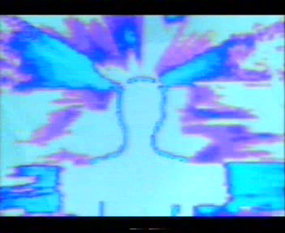
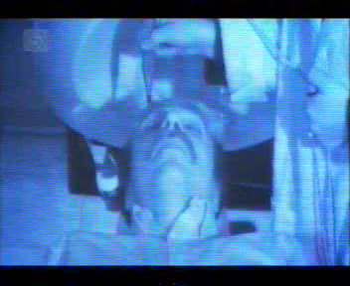

Over the past century a number of systems have been developed which attempt to detect aspects of the HEF. Although the mechanism of each device varies often they rely on an interactive process with the revealed data or image being a result of this interaction. Perhaps the first to provide the first visual evidence of subtle energy fields were Semyon and Valerie Kirlian with their now well-publicised Phantom Leaf experiments in the 1940s (e.g. Gerber, 2000). In the modern era we have available a number of systems including advanced forms of Kirlian, which are able to visualise and/or quantify the HEF.

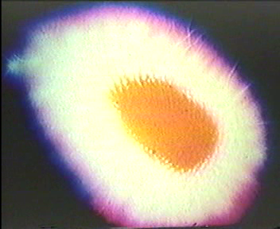
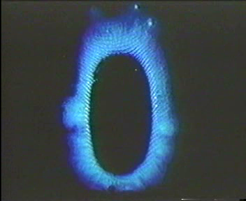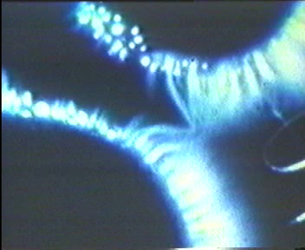

PIP does have similarities to Kirlian in that it provides an ‘indirect’ interpretation of the HEF. However where as with the creation of a Kirlian photograph the image is produced by electrical discharge, with PIP the image is a visualization of light photon interaction with the subtle energies of the HEF. This has the advantage of eliminating the impact of heat and sweat of the hand when carrying out assessments (a common complaint made of Kirlian).

Theory of the Human Energy Field

Structure, Function & Layers

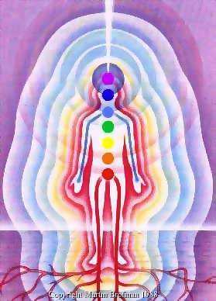
The HEF is the elliptical lattice of Vibrational frequencies that emanates from the human core and permeates the physical body. Understanding variations in this HEF gives us the tools to build a bridge between science and spirituality. The project of scientifically mapping the HEF has continued for many years but has remained a mystery due to a lack of objective equipment to measure its parameters.

CHEFR will provide evidence to show that the HEF is the interface for effective medical diagnosis and efficient non-invasive treatment. This will be achieved through utilisation of new scanning techniques (such as PIP and ESM) that provide an early warning system of possible disease. This is due to the fact that the HEF shows energy imbalances before the physiological disease manifests. This allows corrective measures to be taken before the onset physical symptoms and the subsequent expense of hospitalisation

The etheric field is the densest of all the energy bodies and is closely related to the physical. It is thought to extend up to 2 cm beyond the surface of the skin. CHEFR believes it is the matrix of energy field on which the physical molecules are strung.

CHEFR reasons that the etheric fluid like substance that flows within this layer of the HEF is responsible for the patterns that appear in men’s body hair and on baby’s scalps, a bit like the pattern submerged reeds take on at the bank side of rivers.

It is widely recorded that there are 7 interpenetrating layers of the HEF they are the Etheric body, astral body, mental body, causal body, Celestial body, Ketheric body and the Soul.

There are several important aspects of the Anatomy of the
Human Energy Field

The 9 Layers of the Energy Field

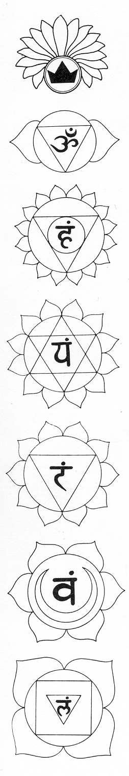
First is the densest physical layer- the skeleton. Next are all the organs, biological systems, muscles, flesh and skin make up the Second layer.
The Third is also a physical layer, an etheric fluid like substance that flows in and out of the skin. This layer is considered part of the physical HEF and plays the important role of removing the etheric toxins from the body. Toxins of high enough frequency that they are expelled directly through the skin and do not rely on either an excretory system, like the kidney, bladder, and urinary tract for liquids, or the intestines and bowels for solids.
The Fourth layer is known as the aura or etheric layer. Here we find the gross outline of the body’s energy plexi or Chakras.
The Fifth layer represents life force carrying the physical gases, oxygen etc, and the vibrationary currents. This is also known as the mental body.
The Sixth or astral layer carries the emotional desires and the most intimate thoughts which are translated through the Soul. The frequencies at this level are incredibly powerful and produce colours directly relating to the emotional experiences; Love - Golden White, Hate - Black, Thoughtfulness - Blue and Joy - Pink.
The Seventh layer is the nine light-layered soul that nestles in the heart chakra and is ultimately responsible for all physical, biological and chemical functions.
The Eighth layer is the celestial body and the spiritual awareness of the Divine Universal Natural Laws. This is the Soul’s self-creating path back to the Godhead and Stardom.
The Ninth layer, the Ketheric body, is the spiritual connection of the Soul with the Godhead.
This interpretation is derived from The Rainbow Colours of Light & Medicina Alternativa, Meher (1985) (see References) and while CHEFR accept there are many varied interpretations of the layers of the energy field over time, this version has proven reliable and shown good correlation with other current theories such as those held by Barbara Ann Brennan – Hands of light (see References).

The Energy Field Template

The energy field is likened to a template on which the physical molecules are strung. It not only surrounds the outside of the body but permeates through it. Yet with photography it is only possible to achieve a two-dimensional image and thus we take a series of views around the body and compare colour symmetries, shapes and patterns from the different angles.

We of course thank Alex Grey for his excellently physiologically and scientifically sound depiction of different layers of the Bio-Energetic Field
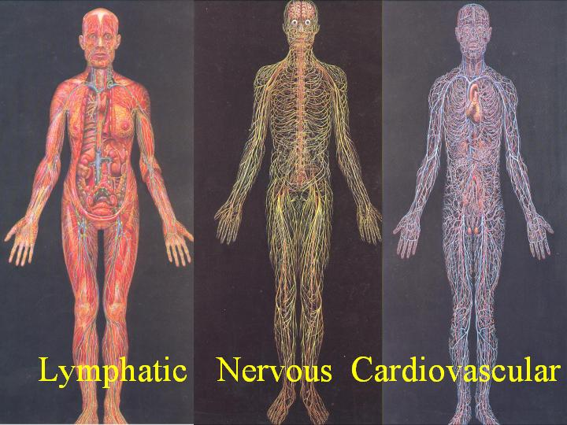
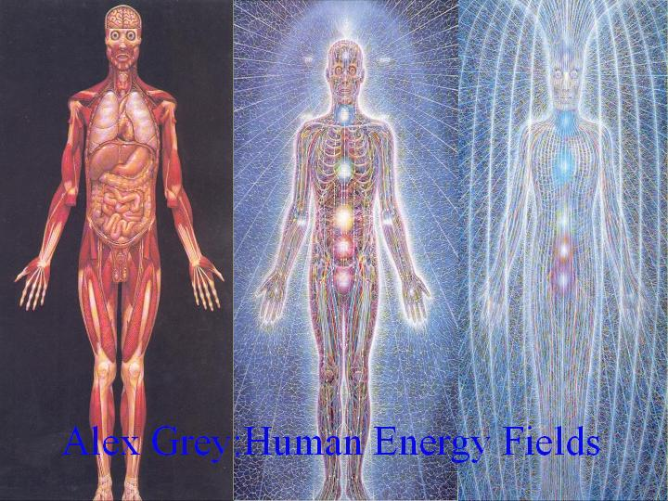
The Chakras (energy centres)

CHEFRs investigations have centred on studying the energy vortices along the spinal cord, commonly known as Chakras (from Sanskrit meaning ‘wheel’) and to show their physiological and psychological connections to the holistic body.

The Chakras have a configuration within and of energy... as a whirlpool is to water. The major Chakras are sub-atomically linked to the endocrine glands. Each chakra is linked to a physiological endocrine gland via nerve plexus and directly affects the gland it is connected to. This in turn has a strong influence on the psychological functioning of the mind. Chakra activity can thus indicate the level of balance and health of the physiological gland and the surrounding areas. Each gland releases or absorbs certain hormones which are responsible for all emotional states.

A key function of the chakra vortices is to absorb the required vibrations and expel toxins and negative vibrations. Each chakra acts like transponder. The seven major Chakras account for the seven colours of the rainbow and the seven major musical notes, seven planets, seven days of the week and seven endocrine glands.
Each chakra spins at their own specific frequencies. The slowest spinning chakra is the base and the highest is the crown. The Chakras draw in energy from the universal energy field that is then distributed via the meridians (channels) of the etheric body to the cells of the physical body.

The etheric body is the densest of all the energy bodies and is closely related to the physical. It is thought to extend up to 2 cm beyond the surface of the skin. CHEFR also believes it is the matrix of energy field on which the physical molecules are strung.

The Position of the Chakras

The chakras of the head
There are differing allocations concerning the crown and brow energy centres and the pituitary and pineal glands. In fact almost half of the relevant literature relates the pineal to the crown while the other half relates it to the brow centre. Until someone is able to do an etheric biopsy a definitive answer may not be forthcoming. As the master gland the pituitary influences the function of many of the other glands, this should clearly indicate its association with the crown chakra. In the same way the pineal gland with cells similar to the optic cells would lend itself to being associated with the brow centre (‘third eye’ chakra). The Oldfield College, on behalf on whom CHEFR conduct this PIP energy field imaging course relates the pituitary to the crown but interestingly Richard Gerber of Vibrational Medicine connects the pituitary with the brow chakra and the pineal with what he refers to as the head chakra (crown) (page 130). Others to make such association include John Evans who suggests that:
“Taking all the evidence into account it is impossible to make any physiological correlation for the highest conscious centre, the crown chakra, except in terms of the pineal and posterior thalamic region” Mind Body and Electromagnetism, pp 39

The crown chakra can be situated on the top of the head in some individuals. In others it can be found in the area of the vertex. The base chakra is located around the perineum. In the male the epicentre for the base is located more to the front of the body, corresponding to the position of the prostate. In the female it is configured more towards the back of the body, corresponding to the cervix. The back of the chakra is opposite the front for the throat, heart, solar plexus and navel Chakras.

The position of the Chakras can vary slightly from individual to individual (e.g. the heart chakra may be found a little to the left or right of the midline in some people. It may be the case that the chakra front and back may exist upon an angle and not travel through the body in a level line. For example the hearth chakra may be lower on the front of the body and higher on the back. In disease states the chakra may be seen to deviate from its normal healthy position (i.e. energy flows may be so disrupted that the chakra is unable to maintain its normal position).

Shapes

The accepted shape of a chakra is circular or elliptical. When Chakras become irregular and contorted it suggests that the endocrine area is out of synch. Wide emanations coming from the body, especially if low/red in colour, are seen as energy leaks. If malfunctioning continues over a period of time, then physical disease may well manifest in the associated organ/chakra area. In low energy states, such as chronic fatigue, the majority of the Chakras are often seen clairvoyantly to be smaller in shape than those seen in ‘healthy’ states.

Barbara Ann Brennan has got some valuable information her two books, Hands of Light and Light Emerging concerning the shape of energy centre or chakras. One of limitations PIP, being 2-dimensional only, is that it can only give us a limited understanding of a chakras functional health.

The Major Chakras and associated endocrine gland

Crown Sahasrara Pineal
Brow Ajna Pituitary
Throat Vishuddi Thyroid
Heart Anahata Thymus
Solar plexus Manipura Adrenals
Navel Svadisthana Pancreas
Base Muladhara Gonads

Additionally there are also 16 minor charkas that exist in such places as the back of the knees, base of the feet, palms of the hands and in the eyes, to name a few. Interestingly these charkas link with the other more major ones. Such an example is the manor with which the palm charkas connect directly to the heart chakra.

This explains how the majority of healing operates through the laying on of hands. In actuality there are as many energy vortices (charkas) as there are pores in the body, however energy passed directly to the major charkas is obviously are more efficient method of affecting the energy systems.

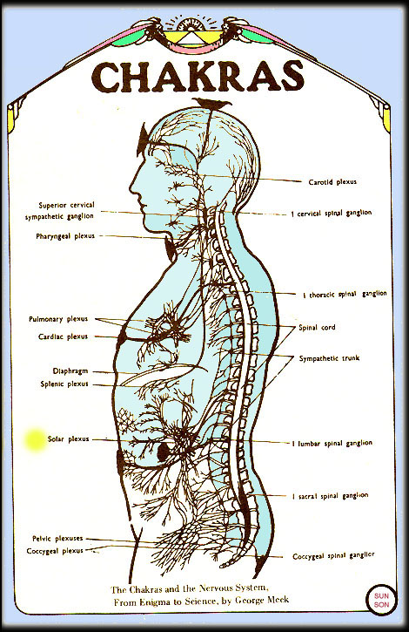
The Energy Centres – Chakra System
Root chakra-muladhara

The root or base chakra is a vortex of spiralling energy that is able to act as a satellite for absorbing geoplasmic earth frequencies, or as an energy trap door for the most physical and slowest of the etheric toxins. In Sanskrit there are many sacred sound vibrations and Yantra God configurations to help the devotee rebalance through vocalisation/chanting and meditation. For example with the root Brahma is the preceding Deity and the square is the geometrical shape. In energy field medicine terms the base chakra’s treatment range is from 0.5 Hertz - 30 Hertz. The colour often associated with this chakra is the slowest on the visible spectrum - Red and it resonates with the musical note ‘C’ or Doe.
This chakra is responsible for the sexual organs and will be disturbed if sexual activity is out of balance. It is associated with the extreme disharmony of Anger and the harmonious state of Kindness.

Navel / Sacral / Splenic chakra-swadisthana
There is confusion about this chakra area, more than any other. The reason for this is that there are in fact several minor Chakras. The Vedic tradition states that all major Chakras are along the central spinal axis. Yet many other traditions have the major splenic chakra off centre above the spleen. In our research the the most important area identified is that of the Navel area, relates to the Pancreas and is measured two finger widths below the navel. Otherwise known as the sacral or naval chakra that corresponds to the Hara of Chinese medicine. The water element is drawn into all biological functions and monitored by this chakra. The Deity is Vishnu and the geometric shape is the circle and the glandular connection is via the Pancreas, but will influence the surrounding digestive and reproductive areas. The note that resonates with this chakra is ‘D’ - Ray and the colour most harmonious with this chakra is Orange.

This chakra is responsible for the pancreas and will be disturbed if attachments are out of balance. These attachments can be to anything from yourself to your house to your parents or partner. It is associated with the extreme disharmony of gluttony and the harmonious state of Chastity.

Solar plexus-manipura
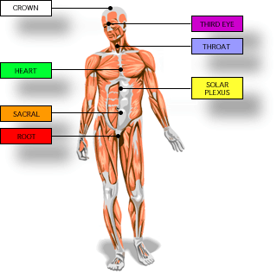
This plexus helps modern medical practitioners understand the concept of Chakras because solar plexus is a term they often use and in a location they know. Intellectually minded types are centred in this chakra. It’s physiological function deals with the fire of digestion and is the chakra that is activated whenever the fire element is generated in the body. It is responsible for and influenced by the Adrenal glands that sit on top of the Kidneys and are responsible for the release of adrenaline and nor-adrenaline. This are our Flight or Flight hormones and influence the sympathetic and parasympathetic nervous systems. The triangle, the note ‘E’ and the colour yellow are also associated with this Manipura chakra.

This chakra is responsible for the Adrenal glands will be disturbed if true expression and incorporation of self is out of balance. It is associated with the extreme disharmony of Greed and the harmonious state of Abstinence.
Heart chakra- anahata
The sun radiates life into the solar system; in the same way the soul seated at the heart chakra radiates life into the body. The green governing colour of balance is associated with this chakra, yet like the Sun it can often appear like a golden yellow. The Soul nestles here and its 2 poles cause the elliptical shape of the HEF.
The Thymus Gland is the endocrine gland that is controlled and influences the heart chakra. This gland is the master immune gland is responsible for the production of lymphatic cells which are the key requirements of a healthy lymphatic system. The Hearth chakra is thus the seat of all healing, whether in oneself or others. The heart Chakra is connected directly to the minor chakras of the hands and thus why so much unconditional love (true healing) work is carried out with the hands.

This chakra is responsible for the Thymus Gland and the psychological state of unconditional love. It is associated with the extreme disharmony of Envy and the harmonious state of Unconditional Love.

Throat chakra- vishuddi
The throat chakra has two predominant colours, orange which stimulates the thyroid gland and triggers the expansion of the lungs, and indigo, which stimulates the parathyroid and triggers the contraction of the lungs. The colour blue, so in the sonic octaves and the element Akasha are associated with this area. The throat chakra is linked in many teachings to the opening of the Third and Fourth ‘eyes’ and the gateway to higher sensory or experiential perception. This chakra obviously holds the key to expression and communication. Importantly it seems that is not just a matter of expressing the true feeling but that those true feelings must be felt listened to otherwise the communication energy exchange is incomplete.

This chakra is responsible for the Thyroid gland will be disturbed if true communication of self is out of balance. The thyroid controls metabolism. It is associated with the extreme disharmony of Sloth and the harmonious state of Zeal.

Third Eye -Brow chakra -ajna
The Brow chakra is an important controlling master chakra and interacts with the Crown both through the influence they hold jointly on the two interactive endocrine glands the Pineal and the Pituitary. This is some debate as to which is controlled by which but it is perhaps more logical and natural to think of them as interdependent and interactive, just as their physical glands. The Brow chakra is also known by the name the ‘third eye’ as it connects most strongly to the Pineal gland. This gland is light sensitive and in reptiles acts as a third eye receiving light information not through the actual eyes. In Humans there are receptors in the eye that don’t travel to the visual cortex but instead move through the Pineal gland. This gland is the seat of our Psychic abilities and where intuition occurs.

This gland is the blood’s watchdog and preserves the radioactive and radio-emanative equilibrium. For example the brow chakra is linked to the pineal gland with its two petals, which gives the mind its duality.
The Pineal (in conjunction with the Pituitary) has full control over the functionality of the other endocrine glands in the body. It is in these glands that we find the roots of the other Chakras. Cerebrospinal fluid constantly washes over the pineal and the pituitary gland and then flows down the spinal column. So this glands are able to send ‘Vibrational’ signals (the bodies own homeopathy through the memory of water) to the other glands instantaneously which controls the spin of the vortex..
This vortex rises in velocity until the speed of light with each chakra having a propensity to resonate with a particular colour on the spectrum. Depending on the signal from the brain (pineal and pituitary) the relevant chakra either absorbs the colour required or eliminates the etheric toxins, whilst the physical body eliminates the solid, liquid and gaseous toxins.
This chakra is responsible for the Pineal gland and will be disturbed if one is holding back ones own knowledge of etheric energetic principle as well as if the body is severly out of balance. It is associated with the extreme disharmony of Lust and the harmonious state of Restraint.
Alex Grey
Crown chakra-sahasrara
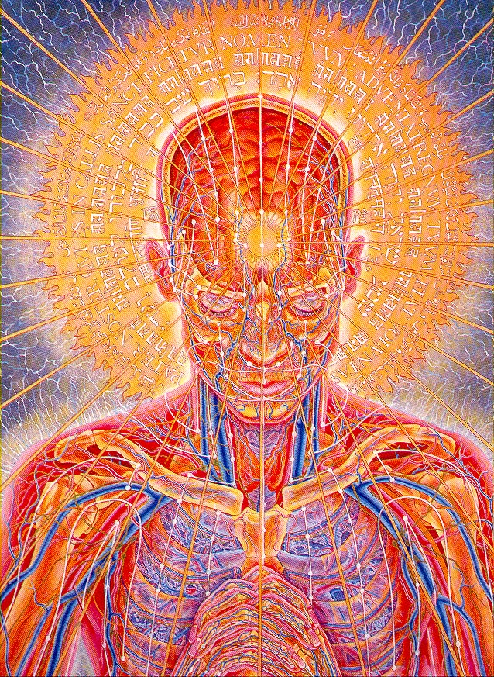
This main chakra is located at the vertex and is known as ‘the thousand petalled lotus’. It is the spiritual link of the individual soul with the rest of existence. The role of this energy centre is well known in the Science of Yoga and in Chinese traditional medicine. Yet a modern scientific understanding of this main chakra is emerging with startling implications for mankind.

This chakra interacts with the Pituitary (as well as the pineal) to be an over aching control over the entire bio-energetic system, physiological, psychological and energetic.

This chakra is responsible for the Pituitary gland and will be disturbed if there is lack of spiritual connectivity and growth. This is the area where we hold onto our egos’s (our personalities). Letting go is the key to opening the cap that contains our energetic awareness inside the body. The Crown chakra is associated with the extreme disharmony of Pride and the harmonious state of Humility.

There are many minor Chakras, which include temple, forehead, jaw, mouth, ear, elbow, palms, fingertips, knee, feet and toes. In fact we have billions of tiny chakras, like pours in the body, absorbing and expelling continuously.
These energy vortices are clearly visible with the latest compression and aura vision devices so there is absolutely no deviation from the ancient Vedic and Avestan Yogic knowledge from that which we actually experience in our laboratories. The Vedas themselves are as good a scientific manual for the structure and function of the Chakras nadis and meridians as the current allopathic literature is for the preparation of medical professionals.
Chakras are shapes caused by energy in motion that is connected through symmetry and a point on the spinal column. Its function is to transmute lower frequencies into higher frequencies and vice-versa. The physical representation of this is to expel toxins (spin them out like a Frisbee) and to attract and tune into particular cosmic colours and vibrations that are currently required for the alchemical processes sometimes enforced by an unavailability of what is required in the dietary range. That is the transmutation of elements one into another and can only occur resonating the element back into high frequency Akasha and the re solidified as the new element required.
With this in mind (as well as work carried out by Fritz Albert Popp) areas that are disharmonious or less healthy will be trying to absorb more energy than areas that are healthy. It seems therefore that physical diseases occur after the HEF has become so severely imbalanced that it can no longer perpetuate quantum healing and sustain the physical matrix against decomposition.
So ultimately the body interacts with the cosmos through light to balance itself. That is why we have a chakra system so that higher frequencies above our range of sight can be utilised by the body.

Colours, emotions & endocrine glands associated with Chakras
Each chakra colour represents a band of frequencies. Harry has found that green crystals are very effective in the solar plexus region and that crystals with a yellow ray are very effective in the heart chakra zone. He theorises that this seeming reversal of (classical) colours could be due to the fact that modern man has to cope with a polluted environment and that green (balance) is needed in the area of the solar plexus and its associated organs of cleansing and elimination.

Chakra Colour Endocrine Sins Virtue

Crown White Pineal Pride Humility

Brow Violet Pituitary Lust Restraint

Throat Blue Thyroid Sloth Zeal

Heart Yellow Thymus Envy Love

Solar Plexus Green Adrenals Greed Abstinence

Navel Orange Pancreas Anger Kindness

Base Red Ovaries/Testes Gluttony Chastity

Colours, Wavelengths, Polarity and Speeds
Colour | In Angstroms | Speeds oscillations per second | Related chakra & endocrine
VIOLET | 4,000 | 732 Trillion | Pituitary / Crown Chakra  Sahasrara
INDIGO | 4,200 | 695 Trillion | Pineal / Brow Chakra  Third Eye/Ajna
BLUE | 4,600 | 658 Trillion | Thyroid- / Throat Chakra  Vishuddi
GREEN | 5,400 | 584 Trillion | Thymus / Heart Chakra  Anahata
YELLOW | 5,800 | 510 Trillion | Adrenals / Solar Plexus Chakra Intestines/Manipura
ORANGE | 6,200 | 474 Trillion | Pancreas / Navel Chakra  Svadisthana
RED | 6,800 | 437 Trillion | Reproductive / Base Chakra  Muladhara

Colours relate to endocrine glands and chakra areas, and as we scale the colours we also climb the musical scales that are in turn are related to planets. Angstrom measures wavelengths

CHAKRAS AND THEIR ASSOCIATED ENDOCRINE GLAND

Chakra Gland
Brief Description of the Gland Function
Crown
Pituitary
Master gland: regulates activity of most
endocrine glands; influences growth,
sex hormones etc. Expanse of spirituality

Brow
Pineal
Controls diurnal (day and night) rhythms;
sleep patterns. Seat of psychic abilities.

Regulates general rate of metabolism:
Throat
Thyroid
body metabolism can 'idle' too slowly or 'rev'
too quickly. Communication delivery zone.

Immune system: defends against infections.
Under activity = low immunity to infections;
Heart
Thymus
over activity = body attacks itself in conditions
like rheumatoid arthritis. Area responsible for
expression of unconditional love

'Fight or flight' mechanism: can be overactive
Solar
Adrenals
with stress, leading to hypertension (high blood pressure);
under activity = tiredness, lethargy, burn out.
Influences digestions and urinary systems.
Expression of true self.

Regulates metabolism and storage of glucose (sugar):
Navel
Pancreas
glucose levels in blood should be stable to provide
constant energy for cells. Levels too high or too low
can lead to problems, including coma.
Attachments to everything.

Ovaries and testes: regulates production
Base
Gonads
of sex hormones, e.g. oestrogen and testosterone.
Base of sexuality and stablitiy.

Chakras & The Endocrine System

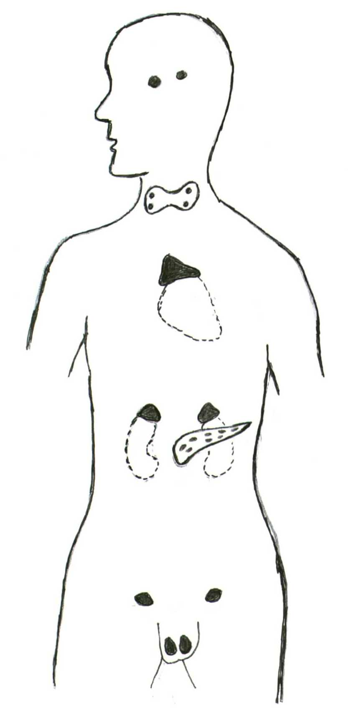
Pituitary
Pineal

Thyroid
**

Thymus

Adrenals

Pancreas

Gonads*

*Ovaries/Testes
** & Para thyroids

The Endocrine system is our most important physiological system. It is responsible for the control of our immune system. All our bodily functions are involved with the immune system and if it is not functioning in a correct manor then the other body systems become susceptible to attack. Each of our Chakras is connected to an endocrine gland thus providing the mechanism for energy to interact with our physical immune system.

THE ENDOCRINE GLANDS

General  Area and location | Specific  Area | Hormone | Function | Hyper-secretion |  |  | Hypo-secretion
P  I  T  U  I  T  A  R  Y  Base of brain has two hormone secreting lobes : anterior and posterior | Anterior lobe hormone | Human growth Hormone (HGH).  …………  Melanocyte stimulating hormone.  …………..  Thyrotrophin  (TSH).  …………….  Adreno-cortico-trophin (ACTH) | Height and Growth  ……….  Melanin in basal layer of skin.  ……….  Controls  Metabolic  Rate in  Thyroid glands.  …………  Controls metabolism of carbos, fats and protein in Adrenal Cortex. | Gigantism  ……………..  ………………  Graves disease  (increase MBR, heart rate, anxiety, intolerance heat, (bowl action).  ………………  Stunted growth, Cushing’s syndrome, hypertension, muscular atrophy, diabetes mellitus |  |  | Dwarfism  ……………..  ……………..  Body slows below normal. Cretinism (at birth)  Myxoedema (untreated cretinism), Goitre (thyroid enlargement).  ……………..
 | Anterior lobe hormone | Gonado-trophins:  Follicle-stimulating hormone.  Luteinising hormone | Sexual dev. and organs.  oestrogen e)  Sperm men  Progesterone  Testosterone | Polycystic ovarian syndrome  Endometriosis  Fibroids  Hyper-Testosterone (WOMEN) hirsutism, amenorrhoea  Hyper-Oestrogen (MEN) Muscle atrophy, Breast growth  Hypo: Addisons disease
 | Posterior Lobe | Antidiuretic hormone (ADH) | Water absorption in Kidneys | Oedema (swelling) |  | Diabetes insipidus
 | Posterior Lobe | Oxytocin | Contracts mammary glands release milk. Contractions child birth
General  Area | Specific  Area | Hormone | Function | Hyper-secretion |  | Hypo-secretion
Pineal body:  Centre of brain |  | Melatonin | Controls body rhythms and responds to sunlight |  | Sleepy and less alert |  | Jet lagged feeling, depressed, SAD
Thyroid Gland:  In the front of the neck  larynx and trachea  Parathyroids:  Four, two either side behind thyroid |  | Thyroxin, triiodothyronine  (in response to TSH) | Iodine needed for hormones to control tissue metab and maintain BMR | Graves disease  (increase MBR, heart rate, anxiety, intolerance heat, frequent bowl action). |  | Body slows below normal. Cretinism (at birth) Myxoedema (untreated cretinism), Goitre (thyroid enlargement).
 |  | Calcitonin | Maintains phosphorous and calcium. | Lowering of blood Calcium by inhibiting loss of calcium from bones
 |  | Parathor-mone | Maintains calcium in plasma, stimulates re-absorption Calcium in Kidneys, activates.  Vitamin D | Hyper-parathyroid. Softened bones--- spontaneous fractures |  | Hypo-parathyroid  Abnormally low blood calcium; tetany- spasm hand + feet by over contraction muscle  Convulsions –over stimulated nerves
 |  | Gluco-corticoids | In response to ACTH (pit + anteri lobes) metabolises  Carbohydrates, fats  + proteins | Stunted growth;  Hyper: Cushing’s syndrome; hypertension; moon face; muscular atrophy; diabetes’s mellitus
 |  | Androgens (sex hormones) | Sexual development ovulation; hair growth. Thought little import to gonads | Hyper-Testosterone (WOMEN) hirsutism, amenorrhoea  Hyper-Oestrogen (MEN) Muscle atrophy, Breast growth  Hypo: Addisons disease
General  Area | Specific  Area | Hormone | Function | Hyper-secretion |  |  | Hypo-secretion
Thymus :  In the thorax, either side of the trachea. |  | Thymic Factor (TF) and Thymic Humoral factor (TF)- promote development of T- lymphocytes in thymus gland thus part of the immune system. |  |  | Lowered immunity and / or stress
Adrenal Glands:  Top of each kidney, 2 parts; adrenal cortex and adrenal medulla | Adrenal Cortex | Mineralocorti-coid  - aldosterone | Regulates salt in body, esp. sodium chloride and potassium | Kidney failure  HBP, too much Potassium =  Abnormal heart beat |  | Addison’s disease, muscular atrophy and weakness; body system slows down.
 | Adrenal Medulla | Adrenaline and  Noradrenaline | Supports sympathetic nervous system: prepares the body for ‘fight or flight’ by speeding up HR, slowing digestive + urinary systems. Increases blood sugar level. Adrenaline powerful vasoconstrictor, ie constricts blood vessels in order to increase blood pressure.
Pancreas: behind and slightly below stomach. Connected to duodenum via pancreatic duct | Islets  of  L  A  N  G  E  R  H  A  N  S | Insulin | Converts glucose to glycogen in liver. Blood sugar levels |  | Hypoglycaemia (low BSL) incl. Hunger, sweating, can lead to coma |  | Diabetes mellitus (high BSL); fatigue, weight loss or coma
 | Islets  of  L  A  N  G  E  R  H  A  N  S | Glucagon | Converts glycogen to glucose in liver
Ovaries :  either side of uterus  Testies : within the scrotum behind penis |  | Female sex hormone oestrogen and progesterone | Female sexual characteristic, tits, hips, hair, period |  | Hypo of Luteinising hormone = polycystic ovarian syndrome. Hyper of oestrogen. Males = muscle atrophy and tits!
 |  | Males sex hormone:  Testosterone and Spermatozoa | Males sexual character, hair voice, muscle, produce spermatozoa |  | Hyper testosterone in Females can lead to virilism, hirsutism and amenorrhoea

Colours in relation to their elements

The concept that elements are frozen rays of light is appealing, it seems that analysis of an elemental particle, of say carbon from an accelerator will reveal a heavy preponderance to yellow in a colour spectrometer.

In the small text are Turenne’s fundamental ray disc whereby the vertical polarisations of any element can be established with a simple radiesthesia technique.

IN THE LARGE TEXT ARE THE PREPONDERATING COLOUR OF ELEMENT

INFRA RED - Hydrogen, helium, lithium,

RED
CADMIUM, HYDROGEN, KRYPTON, NEON. Beryllium, boron, carbon, nitrogen, oxygen, fluorine

ORANGE
ALUMINIUM, ARSENIC, SELENIUM, BORON, CALCIUM, COPPER, HELIUM, SILICON, XENON. Neon, sodium, magnesium, aluminium, silicon,

YELLOW
CARBON, GLUCINUM, IRIDIUM, MAGNESIUM, RUTHENIUM, SODIUM, TIN, TUNGSTEN, MOLYBDNUM, OSMIUM, PALLENDIUM, PLATINUM, RHODIUM.
Phosphorus, sulphur, chlorine, argon, potassium, calcium, scandium, titanium,
LEMON
CERIUM, GERMANIUM, GOLD, IODINE, IRON, LANTHANUM, NEODYMIUM, PHOSHORUS, PRASEODYMIUM, SAMARIUM, SCANDIUM, SILVER, THORIUM, VANADIUM, TITANIUM, YTRIUM, URANIUM, ZIRCONIUM.

GREEN
BARIUM, CHLORINE, KASHMIRIUM, NITROGEN, RADIUM, TELLERIUM, THALLIUM. Vanadium, chromium, manganese, iron, cobalt, nickel, copper, zinc, gallium, germanium, arsenic

TURQUOISE
CHROMIUM, PLUMBIUM, FLOURINE, MERCURY, NICKEL, TANTALUM, ZINC.

BLUE
CAESIUM, INDIUM, OXYGEN. Selenium, bromine, krypton, rubidium, strontium,

INDIGO
BISMUTH, IONIUM, LEAD, POLONIUM, Yttrium, zirconium.

VIOLET
ACTINIUM, COBALT, GALLIUM, NITON. Niobium, molybdenum, technetium, ruthenium,

PURPLE
BROMINE, EUROPIUM, GADOLINEUM, TERBIUM.

MAGENTA
IRENIUM, LITHIUM, POTASSIUM, RUBIDIUM, STRONTIUM.

SCARLET
ARGON, DYSPROSRUM, KERBIUM, HOLMIUM, LUTECIUM, MANGANESE, THULIUM, YTTERBIUM.

ULTRA VIOLET
Rhodium, palladium, tin, iodine, barium,

WHITE
erbium, thulium, hafnium, platinum, gold, mercury, lead, radon, radium, uranium.

Energy field structure and function:
Chi, Prana and bio-energy

The concept of universal energy is the most common theme of all mystical traditions. In Traditional Chinese Medicine (TCM) the term chi or qi is used to describe its presence.

In terms of human anatomy the chi is the bio-energy and in its multiple forms it provides the breath of life. So there is the division between genetic chi and inherited chi, that both reside in the kidneys, and with splenic chi that derives from food, breath and the environment.

In the PIP Energy field image the red streams of tired chi can be seen earthing as healing or rebalancing takes place.
Seven oxygen molecules= prana
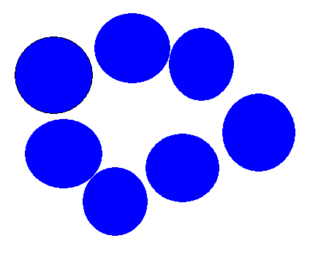

In the Vedas the universal energy is known as prana and is further sub-divided into apana, surpana, upana

The Acu-points and Ashi Points.

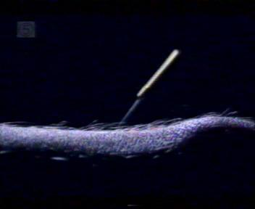
The acu-points (also known as regular points) are the link between the chakra system, as minute energy centres themselves, they are strung along the human anatomy to form lines or channels- these sequences of acu-points in turn define the anatomy of the meridians.

These points are not in dispute as they are being stimulated, needled and monitored by millions throughout the world. A new device called the Acuview-4 is currently being marketed which claims to reveal the exact location and functional health of each acu-point

There is a huge difference of some 70,000 Ohms between the skin resistance at an acu-point and on another part of the skin surface.

The acu-points play a crucial role in eliminating the gaseous toxins from the body, they can get so blocked with the exhaust debris they need to be physically unblocked to retain well-being , like a pipe and pipe cleaner- but in the acu-points case with a needle by an acupuncturist!

The acu-points can be divided into several groups, primary points, confluent points, connecting points and cleft points. Further sub-divisions give us back-shu points, front-mu points, crossing points, influential points, auricular points. Their original Chinese names also reveal their purpose, well points, spring points, stream points, river points and sea points. Others are named after animals, such as fish and rabbit; plants such as bamboo; objects such as cooking vessel and basin and architectural structures, such as gate, window , chimney, courtyard and platform.

The Ashi points are ‘unfixed points’ and tender spots as they are not anatomically standardized and appear nameless but are used especially in pain relief.
The HEF is being emitted from the body by thousands of tiny torch lights, combined they make up the elliptical sheath – the first line of defence of the human body.

The Ming men

The Gate of Life or Ming men is often referred to as the right kidney but as the name suggests the two kidneys could be the gate posts and the swinging gate could be at the right kidney, a theory which could accommodate all of the differing views.

The Meridians Channels
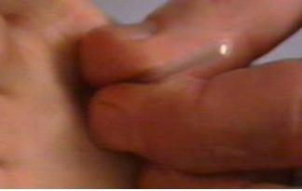
The meridians are an integral part of the body’s energy system. Historically the basis for TCM for over a thousand years, in comparison to modern genetic research an ‘old grand-daddy’. They comprise a network of energy channels and can be thought of as the body’s energy bloodstream. "Meridian" is the most common translation of the Chinese ching-lo (jingluo), Ching means to pass through and lo means a net or to connect (Tsuei, Julia, J, 1996). The network connects hundreds of tiny points in the body where heat, electromagnetic and more subtle energies tend to form in reservoirs. These ‘hot spots’ on the surface of the skin are what are referred to in Chinese medicine as acupuncture points. Although connecting the acupuncture points the meridians are not limited/ restricted to the body surface flowing as they do deep into the body, through the organs and muscle groups and hence can be thought of as the body’s energy bloodstream.

There are twelve main or ‘trunk’ meridians surfacing 12 times throughout the body as channels forming a continuous interlinking chain. Each channel or segment is required for the organ/system it serves.

Below is a table indicating the 12 trunk meridians together with their approximate start and end points.

The trunk meridians | Start/End point of meridian
 | Start | End
Spleen | Left Big toe | Below left arm pit
Heart | Right arm pit | Little finger
Small intestine | Little finger | Ear
Bladder | Between eyes | Little toe
Kidney | Bottom of feet “wellspring of life points” | Below throat
Circulation-Sex | Side of chest | Second finger
Triple warmer | Ring finger | Temple
Gall bladder | Between temple and eye | Fourth toe
Liver | Big toe | Below right breast
Lung | Thumb | Top of chest
Large intestine | First finger | Left of l. nostril
Stomach | Below l. eye | Second toe

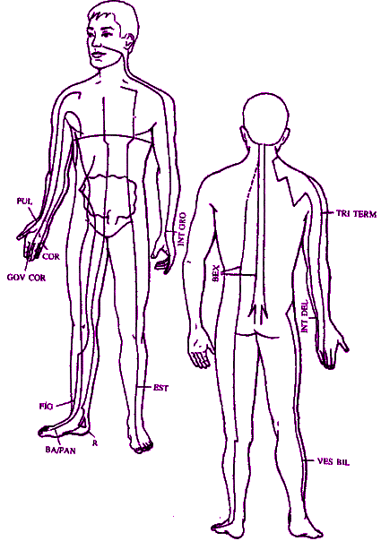
There are two additional energy pathways known as the central (conception) and governing ‘meridians’. The term meridian is used loosely here since their function is different to those of the 12 ‘trunk’ meridians. Rather than being associated a specific organ/system these two energy channels are thought to be responsible for interaction with the surrounding (energetic) environment.

These diagrams show some of the major meridians of the body, in particular the central and governing. Since these have a role of external energy interaction, they are the channels shown most clearly with the PIP.

Each of the trunk meridians flows through and serves at least one organ or physiological system. The role of each meridian often relates to the function of the organ with which they are linked. For example, like the kidneys themselves, function of the kidney meridian is one of purification i.e. it filters toxic energy allowing energies that have been obstructed begin to flow freely.

The meridians affect every physiological system in the body including; immune, nervous, endocrine, circulatory, respiratory, digestion, muscular and lymphatic. Their roles include bringing vitality and balance, removing blockages, adjusting metabolism and even determining the speed and form of cellular change. If the meridians energy is obstructed or unregulated the system it feeds becomes jeopardised.

Since disruptions in energies often precede illness (as with chakra imbalances), meridian readings are sometimes used to predict health vulnerabilities with the possibility of preventing disease.

The Eight Extra Meridians

Including the above-mentioned Governing and Conceptual vessels, which must be linked to the front and rear chakras, are six further extra meridians. These are the Chong, which connects with the kidney meridian and is lateral at the abdomen; the Dai meridian, which connects to the Gallbladder meridian and is on the lateral side of the lumbar region. There are also the Yanqiao, Yinqiao, Yangwei and Yinwei meridians which connect with multiple meridians – all the above mentioned 6 channels share their points with the 14 major meridians this helps strengthen and regulate the flow of Qi in all the channels.

The Twelve Divergent Meridians and Fifteen Collaterals.

The divergent meridians and collaterals ensure the entire body is energised with Qi as they branch from the 12 main meridian channels and so strengthen and join the entire meridian system. The Divergent meridians are mainly in the upper part of the body and run deep within it, consequently they do nor have any surface acu-points and act as extensions to the main meridians.The collaterals are in control of the human body surface and each of them has a connecting point with the main channels.

The Meridian’s dynamics
There are three factors, which affect the dynamics of the twelve meridian channels. Whether they are Zang organ meridians (heart pericardium, liver, spleen, lung, kidney - All solid organs) or Fu meridians, (gall bladder, stomach, small and large intestine, urinary bladder and the sanjiao - The Hollow organs)
The Zang organs are related to Ying - The Fu organs are related to Yang. The second factor is whether they are Ying or Yang. The third is whether they terminate at the hand or foot. There are eight other energy meridians in classical Chinese acupuncture. The main two correspond directly with the Sushumna Nadi with its chakra chain of energy vortices. These eight channels regulate the prana/chi and blood of the whole body.
The Du channel is the confluence of the Yang channels and is known as the governor. The Ren channel is the confluence of the Ying channels and is the responsible channel. The Du is the Back Midline channels and the Ren is the Front Midline channels. The Chong Mi or Vital channel is known as the ‘Sea of Blood’. Dai channel is like a belt around the waist and gives the HEF its horizontal symmetry. The Ying-chiao and the Ying-wei handle the motility and regulation of the Ying channels. The Yang-chiao and the Yangwei channels handle the motility and regulation of the Yang channels.

